Weight Training Assignment: light weight & technique focus

|  |  |
| --- | --- |
| **Complete the following workout with your table partner making sure you have a spotter for bench press: images are provided for each exercise below this chart. We did the Bench yesterday so there is not one for bench press** | |
| Warm up – complete each for 30 secs x 2 | Workout : Upper body focus 2 sets of 8 reps |
| Jump Rope or Jump & Jacks | Bench press (light weight just focus on form & spotting) |
| Bar Lunges | Bicep curls |
| High knees | Tricep dips |
|  | Shoulder Press |
|  | Frontal lifts |
|  | Bent over arm row |

Bicep curl

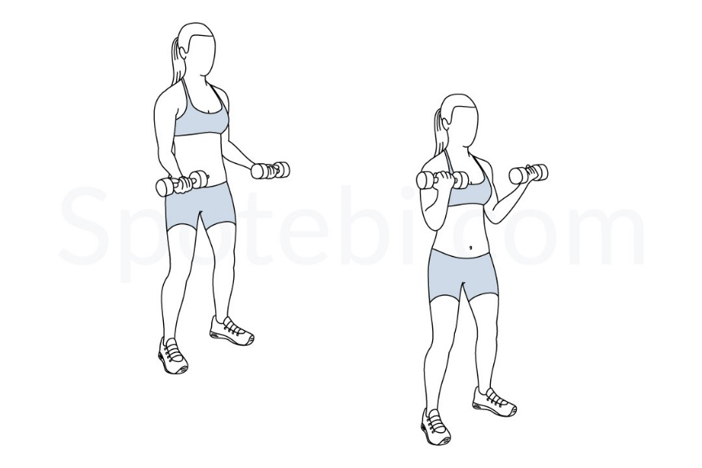

Tricep Dips

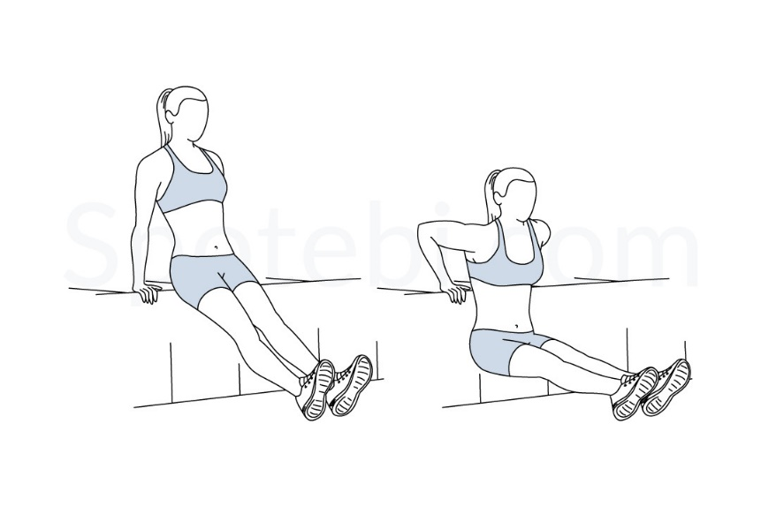

Shoulder Press

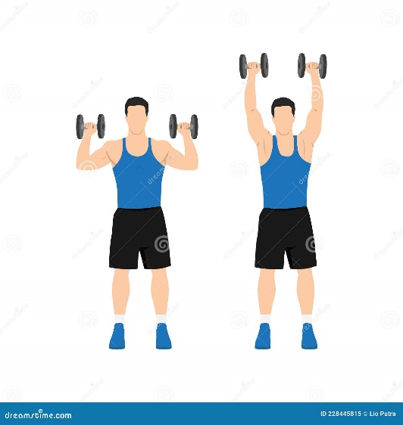

Frontal lifts

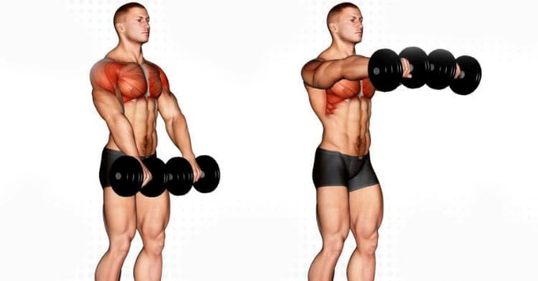

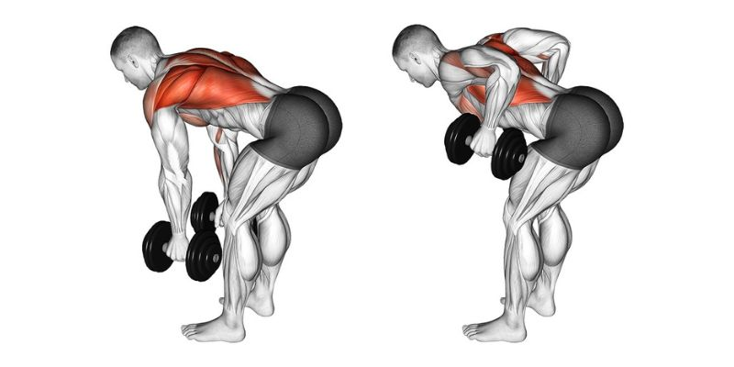Bent over arm row